- Enter 1 or 2 GTC orders on a Hybrid BC.
- Trade Partially.
- After the system recycles next day, check the order’s session based values. They should be all ‘0’, below diagram has non-zero values, which is before the business day was created.

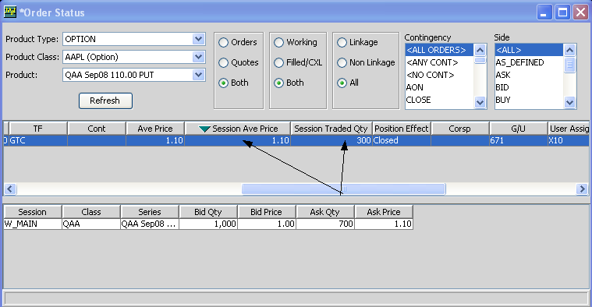

CBOE CONFIDENTIAL AND PROPRIETARY

